What is a painting? Fundamentally, does it allude to a visual arrangement of oil on a fabric canvas surface? In reality, the term can be applied more extensively than that.

Request that a pundit characterizes the craft of painting. The individual will definitely wait on the topic of structure. In craftsmanship, a medium, for example, melodic structure, can be separated into littler classifications dependent on structure, for example, a tune or a drama. In this model, the melodic organization is the medium, and the tune is the imaginative articulation's specific structure. Yet in addition consider how the significance communicated in a melody may have run over if the craftsman had picked an alternate structure, similar to a composed sonnet, for instance.

The meaning of a painting is additionally a matter of structure. Is a painting practical or conceptual? Does it utilize natural or geometric structures? Is the subject a scene or an individual, and does it fall in a specific class, similar to oddity? Was the paint applied to utilize a brush or wipe, or was it splattered and thrown in aesthetic activity? These are questions that can assist you with understanding the type of work of art. So would could it be that joins the field of painting?

The characterizing perspectives that join all masterpieces under the classification of painting incorporate the utilization of specific materials. This implies an artistic creation is generally characterized as comprising of a paint applied to a surface, typically a level, two-dimensional canvas. Be that as it may, that doesn't imply that the main show-stoppers considered artistic creation will be those made of oil paint on fabric canvas. In the broadest sense, spray painting is a sort of painting since it's made with paint - airborne splash paint - applied to a level surface, similar to a divider or piece of asphalt.

There is an assortment of kinds of paints frequently utilized, similar to gum-based paint, acrylic, watercolor, and fresco. The potential outcomes of what medium to apply paint to run from paper to wood, to cowhide and the sky are the limit from there.

Painting is one of the most seasoned artistic expressions. At the point when social orders started making devices and making fire, they were additionally figuring out how to speak to the world in pictures. These photos were recorded in cavern works of art that despite everything exist today. The absolute most established artistic creations known to exist can be found in the Chauvet Cave in France.

The specialty of painting developed after some time, through the hieroglyphics of antiquated civic establishments to the old style and Renaissance compositions that hang in the Louver today. The craft of painting has taken some extreme turns, with present-day types of painting including shading field and activity paint.
COMMERCIAL PAINTING
There's no better method to roll out a quick improvement to the presence of your home than with another paintwork. Renovating is tedious and unattractive, while new finishing sets aside an effort to develop appropriately. In any case, regardless of whether you're cleaning up the entryway patio or making a different search for the kitchen, it's anything but difficult to make a moment sway just by slapping on a new layer of paint.

The reviews at the base of this page will take you to articles that will train you all that you have to think about setting up your home to be painted, picking the correct paints and instruments for the current task, and utilizing the correct method to get paint where you need it to go, both all around. Before a solitary drop of paint goes on a brush, you'll need to be certain everything's prepared, and these articles will assist you with painting your home like an expert.

House Painting Tools

Various surfaces call for various methods for applying paint. Audit these instruments to locate the correct ones for your activity.
Room Painting Techniques

Examine these various strategies for proposals on the most proficient method to utilize your artwork apparatuses successfully and productively.
Painting Interiors

An entryway isn't a story, so you wouldn't paint them a similar way. Look at for this area exhortation on the best technique to paint the numerous surfaces inside your home.
Inside Painting Preparation

Planning is a key piece of any canvas work. These tips will make you go.

Inside Paints
Realize the correct paints to use in each room of the house. These paints have various utilizations, creations, and attributes for you to consider.

Painting Exteriors
Painting in the outside presents a large group of new difficulties. Become familiar with the most ideal approach to spruce up the outside of your home by perusing this article.

Outside Paints
Surface and climate are only two of the elements to consider while choosing the correct paint for your home.
Need to attempt an alternate methodology? Look at some different sorts of Home Improvement.

House painting is regularly a significant advance of the moving procedure. On the off chance that your home or investment property needs a new coat (or two) of paint, you'll need to choose how you need to continue. Do you recruit an expert painter or break out the stepping stool and buy the outside house paint yourself? Contingent upon the size of the task, your period, and whether it's outside or inside house painting work, the appropriate response may be extraordinary. Look into our homework of art tips and deceives to perceive what decision is the best for you. Then Myrtle Beach Painters is best for you.
Myrtle Beach Painters have been caring for their private and business customers all through the state for about 10 years now. They invest heavily in being their confided in painting contractual workers. They treat every single property like it was their own and take fastidious consideration to work superbly. It is forever our objective to surpass your desires both in the completions we give and the kindness of our group. We ensure that you are content with our work long after the paint has dried. They give Myrtle Beach occupants a lot of motivation to make Myrtle Beach Painters their go-to private and business painting temporary worker. They generally put consumer loyalty first and they make it a highlight treat every client like they are our most significant customer. They decide to work with just the best instruments and paints so your property will look staggering for a considerable length of time to come. They need to create associations with our clients, they are our companions and neighbors, and we need you too honey bee cheerful alluding us to your loved ones. Any reasonable person would agree that them spend significant time in putting our clients first and they have the staff with the experience and the gear to take on any task that you may have. They remain by their clients through all aspects of the procedure, from at first picking the correct hues to supplement your home to the last stroll through creation sure that you are happy with the activity. Here is some their works: 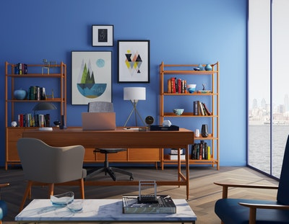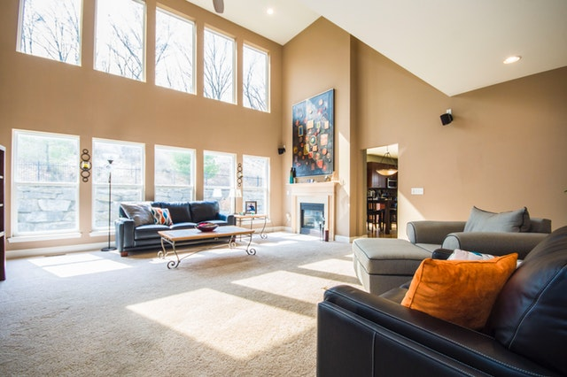
They are the painting contractual worker that you can rely on to take care of business, their fabricated their organization on being the Myrtle Beach painting temporary worker that you can trust. If you don't mind investigate our tributes and surveys, our previous customers will disclose to you that we convey quality work that is done on schedule and inside your financial plan. They are committed to offering our administrations with honesty and they reserve the assessments they give.

